// Gayel (Imad) Abou Imad - 161233

// Myriam (Fouad) Turk – 172038

# TP 1 – Exploring LoRa Technology – Performance Evaluation – Time on Air

**Questions**

* What are the advantages of the LoRa modulation?
* Better battery life: LoRa devices consume very little power making it ideal for battery-powered devices
* Long range: It can transmit and receive data for up to 15 km in suburban areas and 5 km in urban areas.
* Cost effective for large deployment
* Both bandwidth and frequency are scalable
* It is perfect for single-building applications.
* You can set up and manage your own network.
* How LoRa is compatible with LPWAN requirements and constraints?

|  |  |
| --- | --- |
| LPWAN Requirements | Lora specifications |
| Low device complexity and cost | ✔ |
| Reliability under extreme coverage conditions | ✔ |
| Low power consumption: long battery lifetime | ✔ |
| High capacity: support for massive number of low-rate devices | ✔ |
| Simplified network topology and deployment | ✔ |

As previously mentioned in the LoRa’s advantages, this modulation has all the LPWAN

requirements.

LPWAN is mainly about low power, wide area networks. LoRa modulation is able to face the requirements and constraints set by LPWAN since it operates on low power and go in sleep mode when not transmitting or routing other transmission. Besides, it covers large areas because of the spread spectrum technique used.

* 1. **Hardware Platform**
* We are using 2 Arduinos both of them are model **UNO.**
* Number of pins: 32?
* Digital I/O Pins: 14 (of which 6 provide PWM output)

PWM Digital I/O Pins: 6

Analog Input Pins: 6

DC Current per I/O Pin: 20 mA

DC Current for 3.3V Pin: 50 mA

* Memory size:

EEPROM: 1KB

Flash memory: for program storage: 32 KB

SRAM: used for local variables: 2KB

* Main characteristics of LoRa shields:
* Compatible with 3.3v or 5v I/O Arduino Board.
* Frequency Band: 915MHz/868 MHZ/433 MHZ (Pre-configure in factory)
* Low power consumption
* Compatible with **Arduino Leonardo, Uno, Mega, DUE**
* External Antenna via I-Pex connector
* 168 dB maximum link budget.
* +20 dBm - 100 mW constant RF output vs.
* +14 dBm high efficiency PA.
* Programmable bit rate up to 300 kbps.
* High sensitivity: down to -148 dBm.
* Bullet-proof front end: IIP3 = -12.5 dBm.
* Excellent blocking immunity.
* Low RX current of 10.3 mA, 200 nA register retention.
* Fully integrated synthesizer with a resolution of 61 Hz.
* FSK, GFSK, MSK, GMSK, LoRaTM and OOK modulation.
* Built-in bit synchronizer for clock recovery.
* Preamble detection.
* 127 dB Dynamic Range RSSI.
* Automatic RF Sense and CAD with ultra-fast AFC.
* Packet engine up to 256 bytes with CRC.

**4.1. Time on Air**

**Theoretical Computation**

Packet Format :

* 8 symbol PREAMBLE
* Explicit header with header CRC (handled internally by the radio)
* 4 octets HEADER: (TO, FROM, ID, FLAGS)
* 0 to 251 octets DATA
* CRC (handled internally by the radio)

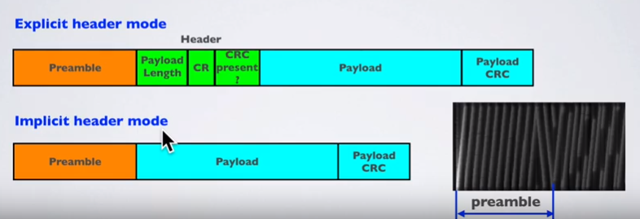

Preamble is used to detect the start of the packet on the receiver.

Payload contains the data

**Describe the scenarios you used for assessing the impact of the different parameters on the ToA.**

* We have changed the following parameters:
  + SF (7,9, 10)
  + BW (20 800, 31 250, 62 500, 5 000 000, 1 250 000)
  + CR (5, 6, 7, 8)
  + Packet size (10, 22 443)

Then using Python, we have changed the Serial Monitor in order to measure the amount of time that Arduino took to send a message. We measured 100 samples of TOA for each of the parameters, then drew a boxplot showing the 100 values and the median values in order to visualize the distribution of TOA for each parameter.

Visualise the experimental results by plotting the ToA as a function of each one of the different parameters. Analyze the obtained results and compare with the theoretical computations. You can superpose the theoretical results and the experimental ones on the same graph.

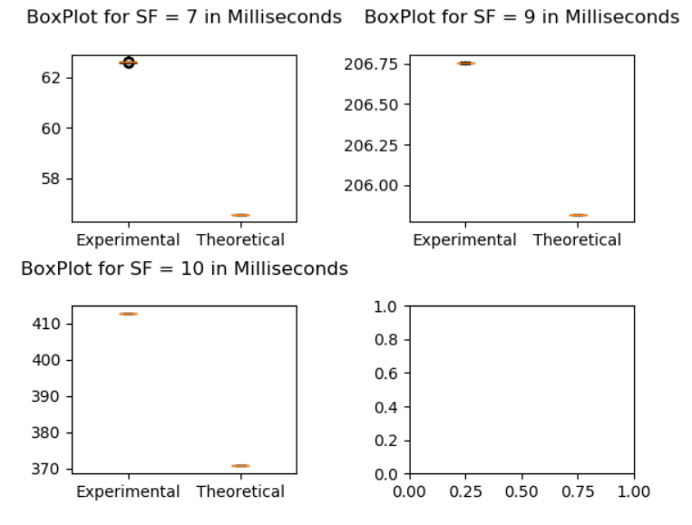**Variation de ToA en fonction du SF et le comparant avec la valeur théorique**

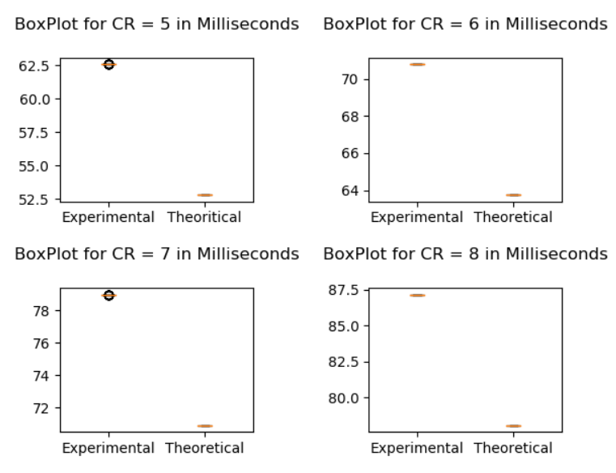**Variation de ToA en fonction du CR et le comparant avec la valeur théorique**

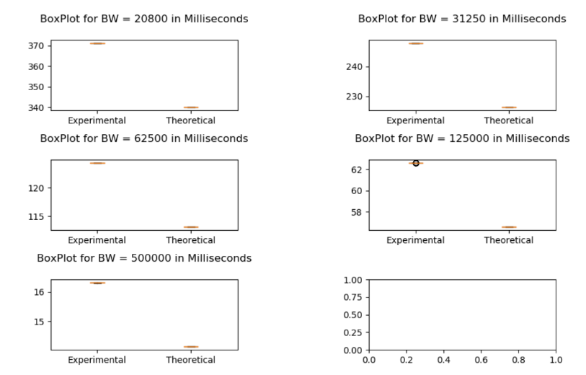**Variation de ToA en fonction du BW et le comparant avec la valeur théorique**

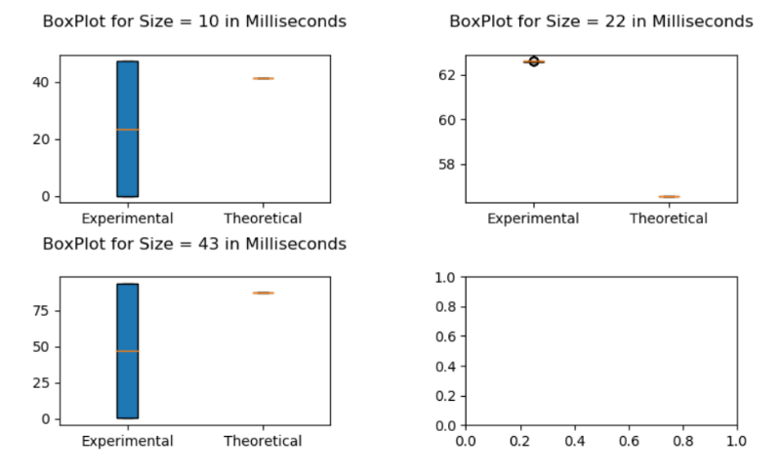**Variation de ToA en fonction du size du message et le comparant avec la valeur théorique**

**Join commented extracts of your code and raw data in attached files.**

Code I : (listener qui va écouter Arduino en utilisant le serial correspondant)

Dans le repertoire

Code II : (code qui dessine SF en fonction du temps en utilisant matplotlib)

Dans le repertoire